NI Apprenticeship Programme Approval

The NI Apprenticeship Programme Approval Process is designed to approve apprenticeship programmes that develop and assess the candidate’s occupational skills along with their ability to apply these skills and to work effectively in a nuclear context.

Approval of a Apprenticeship Programmes delivered in a nuclear context considers the component parts holistically to be assured that apprentices successfully completing the programme have:
- met the requirements of their apprenticeship
- demonstrated that they can apply their skills effectively and safely in a nuclear context
- Satisfied the technician grade requirements for membership of the Nuclear Institute, including the applicable standards for professional registration, e.g. Eng Tech*
*To ensure the standards required for professional registration are maintained it is a requirement of approval that a Registered Professional Engineer confirms that each candidate has complete all of the approved components of the programme and acts as a signatory on the associated proof of completion submitted to the NI.
Joint Programme Approval with the National Skills Academy for Nuclear

Programmes that are successfully approved through the NI’s Apprenticeship Programme Approval Process will benefit from joint recognition by both the NI and National Skills Academy for Nuclear (NSA Nuclear).

Recognising the importance of developing, maintaining and recognising high standards of nuclear professional practice in the sector, the Employer membership body NSA Nuclear, has formed a close collaboration with the NI.
Through this collaboration a common professional standard known as the Nuclear Delta is applied to both Nuclear Institute professional body membership and to joint NI/ NSA Nuclear approval of training and professional development programmes, including apprenticeships. By applying a common, independently defined standard (the Nuclear Delta) to programme approval and to individual professional recognition, we are enabling a shared, sector wide framework for developing nuclear professionalism. This can be applied at an organisational and individual level.

The Apprenticeship Programme Approval Process has been jointly developed by NI and NSA Nuclear and enjoys the support of the employer members of NSA Nuclear. The approval process is implemented by the Nuclear Institute through their expert volunteer base who are registered Engineering and/or Science professionals. Formal programme approval decisions are ratified by the NI Membership Committee.

In light of this industry recognition, applicant organisations are expected to be employer members of NSA Nuclear.

The Apprenticeship Programme Approval Process

This involves two steps:
- Mapping of qualification(s) delivered within the programme to the Nuclear Institutes membership criteria, which include the standards for professional registration (e.g. EngTech, IEng, RSciTech).
- Programme approval to seek evidence of the development of nuclear professionalism through the design, delivery and assessment of the programme.
The process will use a 4C’s Approval Framework considering:
- qualifications and training inputs (Content);
- the nuclear aspects of the learners work setting (Context);
- how learning and experience combine to develop personal behavioural safety (Commitment);
- how the programme assesses each individual’s nuclear professionalism (Competence)

The 4Cs Framework criteria are used to assess whether programmes develop essential nuclear specific skills, knowledge and attitudes to the level specified for technicians in the NI’s Nuclear Delta. Many of these skills may be developed through formal qualifications; others may be nurtured through employment within a nuclear setting and/or through additional training and role assessments.

Please note: The 4C’s Approval Framework is included at Appendix 1, and the requirements of the Nuclear Delta are included at Appendix 2

Figure 1 The relationship between qualifications and other components of an apprenticeship framework and the wider approval of a Nuclear Apprenticeship Programme.
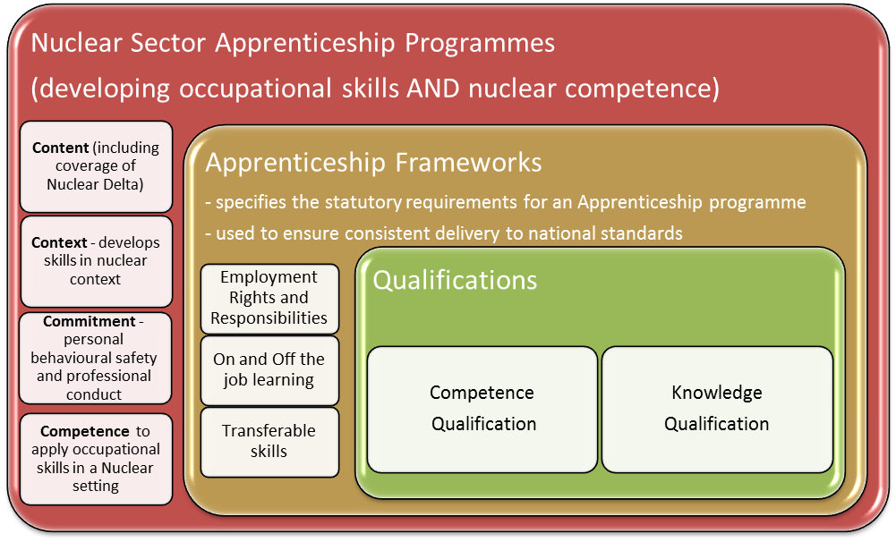

Steps to getting your apprenticeship programme approved

The stages of the Programme Approval Process are as follows;

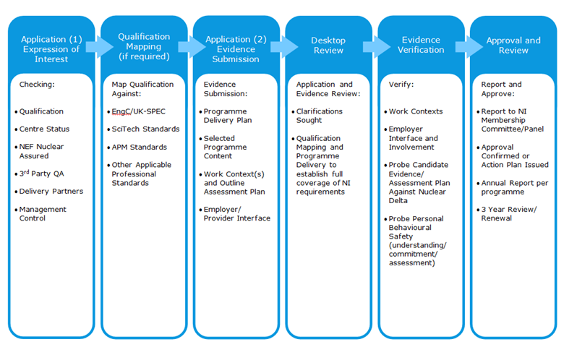
Application (1) Expression of Interest Form (PAF1)

This initiates the approval process by gathering outline information about your apprenticeship programme(s). You can include one or more programmes in your Expression of Interest (EoI). If including more than one programme you should provide the information requested for each programme, as follows:

1.5 Title of programme(s):

1.6 Purpose and scope of the programme(s):

1.7 How long programme(s) operating in current format:
Numbers on the programme:
Average annual intake:
1.8 Title and level of qualifications embedded in the programme(s):
- Awarding body:
- Reference number:
(e.g. EAL, NVQ level 3 Engineering Maintenance 100/3157/1)
- Units/Pathway(s) undertaken by apprentices (please specify or attach a list)
1.9 Name of Training Provider Partner(s):
1.10 Is scheme approved by another Professional Engineering Institution, if so which?
The information provided in 1.8 enables the NI to determine what qualification mapping is required to process your application. It is important that you check the currency and accuracy of this information prior to submission. For example, qualifications are periodically reviewed and re-approved which results in changes to reference numbers and can include changes to the qualification structure, unit titles and content.

We require a list of the units undertaken by your apprentices under each apprenticeship programme. This enables us to identify where mapping of the qualification, and particular units or pathways within it, has been previously completed by the NI or another licensed Professional Engineering Institution. This can save time and will enable your application to be progressed smoothly.

The NI Administrative Team will check EoI’s to confirm the proposed programmes are in scope and that qualification details are current and accurate. In the event of any queries the NI Membership Officer will contact you for clarification.

Once checked and confirmed as in scope and complete, The NI Membership Officer will contact you to request submission of a full application form and supporting evidence.

Qualification Mapping

Where required, the NI will organise for the qualification(s) included in your apprenticeship programmes to be mapped against the appropriate Professional Standard (e.g. EngTech, RSciTech). Mapping is undertaken by a panel of NI Approving Volunteers and is usually completed within 3 weeks of receipt of full details of the qualification.

You will be advised of the outcome of the qualification mapping. The Lead Assessing Volunteer will contact you to discuss any implications should the qualification be found not to map to the professional standard.

Application (2) - Application Form and Supporting Evidence Submission

The information requested in the Application Form (PAF2) is largely self-explanatory. However, we do require the following information. If you have any queries please contact the membership team on 0203 475 4701 or by email membership@nuclearinst.com

- The fully completed and signed application form.
- Explain the relationship between your organisation and the training provider – how do you ensure the apprentices are being taught what you want them to be taught? Do regular meetings take place for example?

- Scheme handbook (or other document covering the following items):
- Outline of scheme,
- Scheme content,
- Job roles, including descriptions, the apprentices go on to undertake,
- How is what they do on the job verified?
- Any functional skills/ additional training the apprentices undertake,
- Qualification programme/ timetable over the period of the training,
- Have any of the qualifications been mapped previously by another PEI?
- For mapping the qualification against the requirements of the UK-SPEC we need the following information for each of the schemes:
  - awarding body,
  - qualification name/number,
  - training provider,
  - mandatory units,
  - optional units, i.e. do you as the employer specify modules the apprentices need to complete a number of?
Please highlight any differences between the different schemes, if applicable.

- Details of any nuclear specific training courses undertaken, internal or otherwise to cover -
- Nuclear safety:
  - are apprentices involved in daily safety/ quality briefings?
  - understand the implications of poor quality in the nuclear environment
  - that they know how to report unsafe acts or behaviours
  - understand the concept of human performance/ error-reduction
  - awareness of safety track record of nuclear industry
- Nuclear security:
  - Why are security procedures needed? What procedures do the apprentices undertake?
  - Procedures for control and management of radioactive materials
- Basics of nuclear physics

- Details of apprentices support arrangements, e.g. mentor, line manager
- How are the mentors/ line managers supported? What training is given to them?

Points of particular note:
Section A: Information about the Company and the Scheme replicates the information previously supplied in your Expression of Interest Form(s). This is to ensure the NI Approvals Panel work with current information in the event of changes since your original Expression of Interest.
Please ensure you identify the name of your Company and the schemes for which you are applying on the application form. If the remaining information is unchanged, please feel free to attach copies of your completed EoI form(s) instead of duplicating the entries in Section A.

Section C: Approval Criteria Before completing this section you should familiarise yourself with the NI’s 4C’s Framework for Apprenticeship Programme Approval (Appendix 1) and consider how your programme develops apprentices to meet the Technician Grade Requirements of the Nuclear Delta (as detailed in Appendix 2).

Many organisations find it challenging to evidence Personal Behavioural Safety. You should consider how the programme prioritises and develops personal behavioural safety.
- How does the programme ensure the active participation of each apprentice to maintain and contribute to the safety culture?
- How do you assess each individual's personal behavioural safety practice to the standard specified in the Nuclear Delta?
Examples of evidence may include: individual apprentice’s use of condition or error reporting systems, participation in routine safety or performance reviews (formal or informal), evidence generated through day-to-day operational or QA procedures, (e.g. Design approval or task completion and sign off processes); improvements or suggestions initiated by apprentices.

While some evidence of personal behavioural safety may be available in assessed qualification portfolios, you are encouraged to look beyond formal training and assessment records to identify other evidence that may arise from routine operating or quality assurance practices in your workplace.

The NI Approval Panel is looking for evidence that the work context in which the apprenticeship takes place:
- extends understanding and practice of safety, including nuclear safety and security, to the level specified in the Nuclear Delta.
- develops and enables the application of occupational skills in a nuclear context to be assessed (as applicable to the job role and organisational context).
For Site Licence Companies and contractors working in nuclear facilities, this can be straight forward and evidence can be generated through day to day activities, compliance with operational procedures, etc.
For organisations working in the supply chain, demonstrating how the apprentices work context fulfils these requirements involves consideration of the job role and organisational context. Factors such as understanding nuclear sector client requirements, design specifications, the intended use and the environment in which the product or service is to be deployed, quality criteria, tolerances or thresholds, understanding the impact of errors and acting to identify and report any issues that could affect nuclear safety would all be relevant. Similarly, participation in operational processes and compliance with procedures designed to manage such factors would also be relevant.

Any features of the programme designed to develop the apprentices understanding of the nuclear context should also be noted in the application.

Appendix 1 – Nuclear Institute’s 4C’s Framework for Apprenticeship Programme Approval
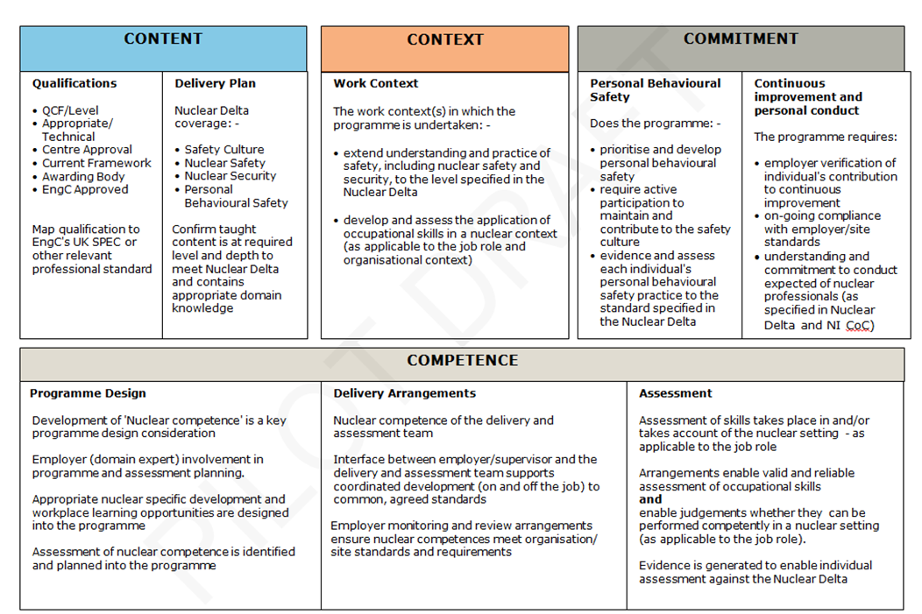

Appendix 2 – Requirements of the Nuclear Delta

1. Nuclear Safety and Security Culture

The Nuclear Delta™ requires an accredited nuclear professional to demonstrate an understanding of the terms ‘Nuclear Safety Culture’ and ‘Nuclear Security Culture’. As a Member of the Nuclear Institute you are able to demonstrate that you can;
- explain what is meant by Nuclear Safety Culture
- explain what is meant by Nuclear Security Culture
2. Personal Behavioural Standards
The Nuclear Delta™ requires an accredited nuclear professional to demonstrate a commitment to ‘personal behavioural standards’.

As a Member of the Nuclear Institute you are able to demonstrate that you;
- challenge unsafe acts and behaviour and reinforce safe practice appropriately and effectively.
- challenge acts which could undermine security and reinforce security practice appropriately and effectively.
- apply nuclear safety principles to check that your decisions and work activities support safe nuclear operations.
- apply human performance and error-reduction tools within your role.
- work against complacency, maintaining and encouraging a questioning attitude.
- contribute to continuous improvement, maintaining an ‘it can happen here’ attitude.
- use organisation and/or site reporting systems effectively to learn from experience.
- accurately and factually represent the pros and cons of nuclear technology, when called upon to do so.
As a Member of the Nuclear Institute you know and understand;
- your role, responsibilities, boundaries of your authority and reporting lines in respect of nuclear safety and security.
- the roles and responsibilities for safety of others within your organisation and/or site including, where applicable, the roles and responsibilities of Site Licensees/Authorisees and Contractors.
- how human error has contributed to previous nuclear industry accidents, and recognise how avoidance of human error contributes to future safe operation.
- the principles of nuclear safety, how these apply to your work and their importance as a foundation for sound decisions and actions.
- the contribution you, your activities and/or the products of your work make to maintaining nuclear safety and security.
- how to apply human performance and error-reduction tools within your role
- the safety track record of the nuclear industry, including awareness of key incidents, identified causes, contributory factors and resulting lessons learned.
- the importance of employee vigilance and reporting to maintaining an effective nuclear safety and security culture.
- the range of public opinion regarding nuclear sector operations.
- how to present a high level of personal professional responsibility for nuclear safety and security.

3. Nuclear Safety and Technology

The Nuclear Delta™ requires an accredited nuclear professional to demonstrate an understanding of ‘nuclear safety’.

As a Member of the Nuclear Institute, at a level appropriate to their responsibilities and grade you are able to demonstrate that you;
- discharge your role responsibilities for safety, within the limits of your authority.
- accept accountability for maintaining safety standards within your area of responsibility, contributing to identifying and resolving any shortfall in meeting standards.
- identify and understand the potential consequences arising from planned activities and their implications for safety and security.
- take appropriate action when faced with unexpected or uncertain conditions to prevent or minimise the risk of a safety incident, unsafe action or other unintended consequence of your work (or work product).
- recognise what is safety critical.
- understand and comply with nuclear and environmental regulatory requirements to protect people, property and the environment from hazards (accidents, malfunctions and natural events).
- apply operating procedures and safe systems of work to meet organisational and regulatory requirements and minimise risk of exposure to radiation.
- work activity to minimise potential for contamination, as applicable to your role.

As a Member of the Nuclear Institute you know and understand at a level appropriate to your responsibilities and grade the following topics:
- What is meant by Nuclear Safety
- The regulatory regime within which the nuclear industry operates, as applicable to the organisation, sub-sector and national context in which you work.
- The fundamentals of heat removal and containment relating to nuclear safety, including the need for reactor post shut-down cooling and decay heat removal.
- The principles of nuclear science and engineering, at a level, breadth and depth applicable to your role and working environment, drawn from the following areas;
- Structure of the atom e.g. characteristics of electrons, neutrons and protons; mass number, atomic number and isotopes.
- Nature and effect of radiation, e.g. sources, applications of radioisotopes
- Types of radiation, including, radioactive decay; half-life; ionising radiation - interaction with matter.
- Methods of reducing exposure to radiation - reducing exposure; equivalent dose; time; distance and shielding.
- Control of contamination – definition of contamination; control methods; contamination monitoring.
- Science and engineering of the nuclear fuel cycle including:.
    - Criticality.
    - Nuclear Reactors.
    - Reactor Safety and Hazards.
    - Nuclear Weapons.
- Defence-in-Depth, including redundancy, diversity and segregation.
- Emergency procedures, potential emergency situations, alarms and appropriate responses.
- Awareness of legal requirements for handling radioactive waste and how these apply to your work role and activities.

4. Nuclear Security
The Nuclear Delta™ requires an accredited nuclear professional to demonstrate an understanding of ‘nuclear security ’in the nuclear industry.

As a Member of the Nuclear Institute, at a level appropriate to their responsibilities and grade, you are able to demonstrate that you;
- discharge your role responsibilities for nuclear security, within the limits of your authority;
- accept accountability for maintaining nuclear security within your area of responsibility, contributing to identifying and resolving any shortfall in complying with requirements;
- identify and understand the potential consequences arising from planned activities and their implications for nuclear security.
- take appropriate action to prevent or minimise the risk of a security incident or other unintended consequence of your work (or work product).
- recognise what is security critical for their role.
- comply with nuclear security and environmental regulatory requirements to protect people, property and the environment from threats (malicious acts)

As a Member of the Nuclear Institute you know and understand at a level appropriate to your responsibilities and grade the following topics:
- What is meant by Nuclear Security.
- The nature of potential security threats and the reasons why controls are required.
- Work place access and restrictions, including:
  - personal access to site and restricted areas, including use and protection of security passes.
  - restrictions on items brought onto, removed or used on site.
  - general security principles and practices (need to know; steps to avoid accidental security breaches; complacency; vigilance; commitment to following specific policies, procedures and good practices).
- Management of sensitive information, including:
  - local policy, requirements and procedures, including document classification system.
  - correct handling and storage of information, as it applies to your job role.
  - correct IT security practices (locking PCs; password strength and protection; use of laptops, especially off-site).
- Risks of transmission of sensitive safety and security information and precautions when using electronic communications (telephones, mobiles; email, fax and social media).
- Response procedures, alarms and appropriate responses to nuclear security incidents and events.

INSAG 15 defines safety culture as “that assembly of characteristics and attitudes in organizations and individuals which establishes that, as an overriding priority, nuclear plant safety issues receive the attention warranted by their significance.
IAEA Nuclear Security Series No 7 & ONR TAG CNS-TAST-GD-002 (Rev 0) defines Nuclear Security Culture as ‘The assembly of characteristics, attitudes and behaviour of individuals, organisations and institutions which serve as a means to support and enhance nuclear security’.
IAEA in their Safety Glossary define Nuclear Safety as “The achievement of proper operating conditions, prevention of accidents or mitigation of accident consequences, resulting in protection of workers, the public and the environment from undue radiation hazards.

