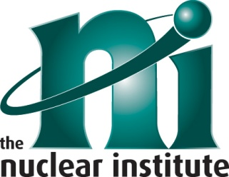
The Nuclear Institute Young Professional Award

Closing Date for Applications:
Please return completed form by email to communications@nuclearinst.com reference ‘NI Awards 2017’ by 31 October 2017.
Full Name of Nominee
Job Title
Date Employment Commenced in the Nuclear Industry
Employer Name
Brief description of why you consider this employee should be awarded the NI Young Professional Award 2017. Please describe how they meet aspects of the Nuclear Delta™. Please see the conditions and full version of the Nuclear Delta™ for assistance.
http://www.nuclearinst.com/write/MediaUploads/Policy%20Docs/Nuclear_Delta_membership_definition_V9.pdf

Please feel free to hand write or type but overall no more than two sides of A4 with a font size we can read!

Please describe how you and your employee would support the Nuclear Institute if winning this award

Please give a correspondence name and address for your Organisation:
Title
First Name
Surname
Organisation
Address
Postcode
Signed |  | Date
Tel No:
Email:
The Prize will be presented at the Nuclear Institute’s Annual Dinner on 7 December 2017, with the prize winner attending the event for free. If the prize winner should be unable to attend, the prize will be presented at your ceremony or at an agreed time. Please state below the applicant’s availability.
EITHER Can attend Annual Dinner on 7/12/2017
OR Date and time of your Awards Ceremony where you will present the prize or preferred date if no Ceremony
Please include the contact details of your Communications/PR contact

