Discover some of the benefits of NI membership in 2021

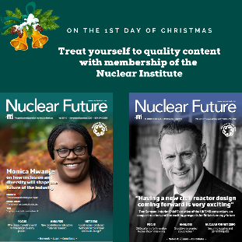  Figure 1 The only professional body that is 100% about the nuclear industry. Read Nuclear Future for free as a member of the NI. Join the NI during January 2021 and receive a free gift. | 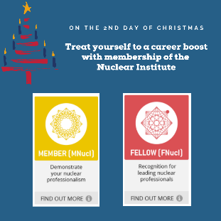  Figure 2 Become a nuclear professional by applying for MNucI or FNucI. Add other registrations such as CEng/IEng, CSci, CEnv, EngTech or REnvTech. Apply in January to qualify for half price application fee https://www.nuclearinst.com/Membership-Resources | 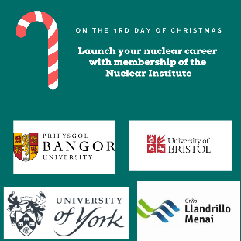  Figure 3 Students - get free membership if your university joins as an Education Affiliate or join as an Affiliate yourself for just £20. Benefit from local branch networking as well as all the other benefits of membership. | 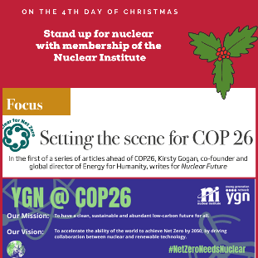  Figure 4 Make sure that nuclear leads the agenda on the world's carbon reduction plans - get involved with our YGN and make your voice heard at COP 26. Join in January for a free gift and the chance to get involved.
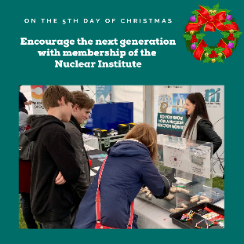  Figure 5 Our strength is our volunteers. Can you help the next generation to become leaders for nuclear? Join the NI to help educate society about the valuable role nuclear plays in our energy mix. https://www.nuclearinst.com/NI-Volunteer-Network | 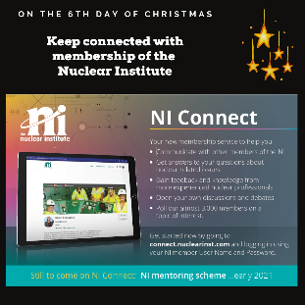  Figure 6 Keep connected with your industry colleagues. Discuss, debate, vote and help - our newest membership service to help us meet our aims: Network - Learn - Contribute. Join in January to qualify as a mentor/mentee. | 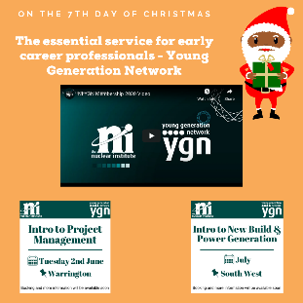  Figure 7 Be part of the YGN and shape the NI's future role in supporting its members and their careers. The YGN gives you an essential career boost https://www.nuclearinst.com/Communities/NI-Young-Generation-Network | 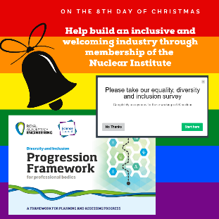  Figure 8 Help the NI to develop its plan for inclusivity in its membership and contribute to the first industry survey on its existing diversity. You too can help us make nuclear a number 1 destination career for all www.nuclearinst.com
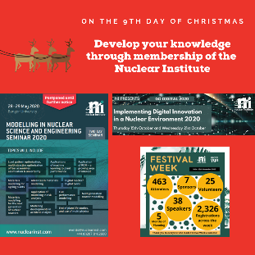  Figure 9 Professional development - the key to developing your expertise and knowledge in nuclear. NI events cover a range of technical and non-technical contents and members receive substantial discounts to attend. Join during January for an extra free gift. | 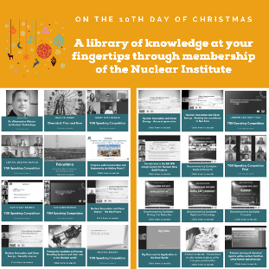  Figure 10 When time is at a premium and you want to learn in your own time - visit the NI's extensive webinar library for technical presentations, speaking competitions and more - all free to members. | 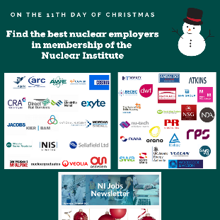  Figure 11 Our company members want the best for their employees and demonstrate their commitment to their professional development through membership of the NI. You will also see many of them advertising their job roles through the NI's monthly newsletter | 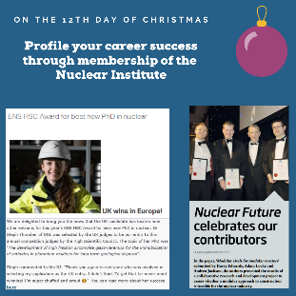  Figure 12 Prizes and awards - NI has a range of them for the Hinton Award, academic achievement, best technical paper for Nuclear Future and speaker prizes. Supporting the promotion of other prizes means we can help boost our members' success still further.

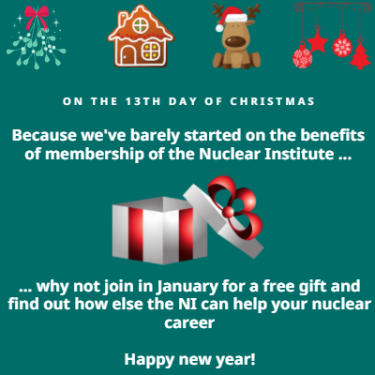
Figure 13 There are lots more benefits to being a member of the NI - why not make 2021 the year that you commit to nuclear. Go to https://www.nuclearinst.com/associate-application to become an Associate member today.
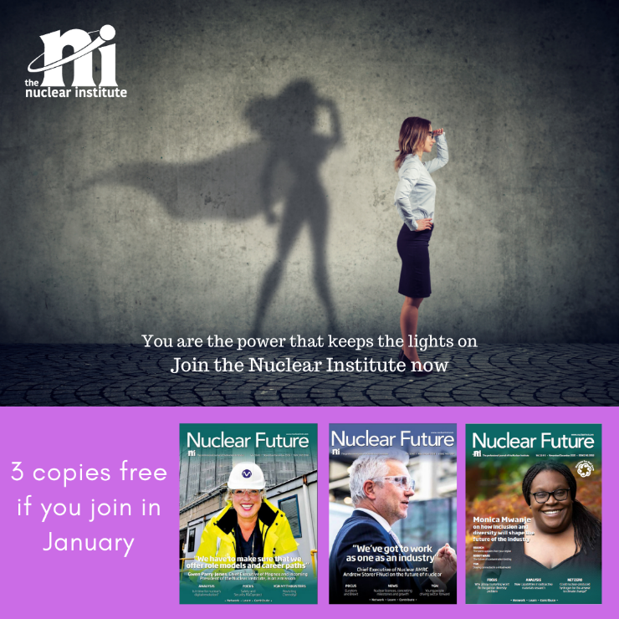
Figure 14 Nuclear superheroes wanted - apply here https://www.nuclearinst.com/associate-application

