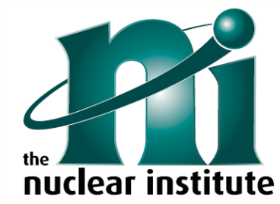
Nuclear Institute Western Branch Committee Vacancies
Role | Description
Events Secretary Support (Plymouth Area) | Provide support to the Lead Events Secretary in arranging events in the Plymouth area.
Events Secretary Support (Bridgwater/Hinkley Area) | Provide support to the Lead Events Secretary in arranging events in the Bridgwater / Hinkley area.
Events Secretary Support (Bath Area) | Provide support to the Lead Events Secretary in arranging events in the Bath area.
Events Secretary Support (Gloucester/Cheltenham Area) | Provide support to the Lead Events Secretary in arranging events in the Gloucester / Cheltenham area.
Branch Dinner Secretary | Through a phased handover, help arrange the Western Branch’s Annual Dinner.
Branch Treasurer | Through a phased handover, help manage the Western Branch’s finances
Membership Representative | Through a phased handover, help support the Western Branch’s membership activities.
Branch Education and Training Representative | Through a phased handover, help support the Western Branch’s education and training activities, and contribute to NI HQ’s E&T committee.
Branch Communications Support | Provide support to the Lead Communications Representative.
Branch Young Generation Network (YGN) Representative | Provide an interface between the Western Branch and the YGN committees.
Volunteers for outreach | Part of the team manning stands at festivals and science fairs

For more information, contact Chair (Anna Ellis) at westernchair@nuclearinst.com, or Secretary (Lauren Bennett) at westernbranch@nuclearinst.com .

