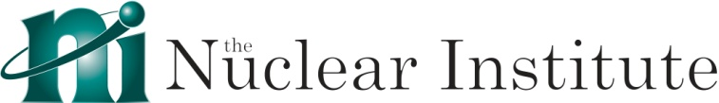 |  |  |  |  |  |  |  |  |  |  |  | Instruction to your  Bank or Building Society  to pay by Direct Debit
Please fill in the whole form including official use box using a ball point pen and send it to: |  |  |  |  |  |  |  |  |  |  |  | Service User Number (SUN)
The Nuclear Institute  Phoenix House  18 King William Street  London  EC4N 7BP |  |  |  |  |  |  |  |  |  |  |  | 2 | 5 | 0 | 0 | 2 | 3
FOR OFFICIAL USE ONLY
This is not part of the instruction to your Bank or Building Society.
Important – Please complete these details:
Account Holder(s) Name & Address:
Name:
Address:
Postcode:
Email Address:

Name(s) of Account Holder(s)
Bank/Building Society account number
Branch Sort Code |  |  |  |  |  |  |  |  |  |  |  | Instruction to your Bank or Building Society  Please pay The Nuclear Institute Payments Direct Debits from the account detailed in this Instruction subject to the safeguards assured by the Direct Debit Guarantee. I understand that this Instruction may remain with The Nuclear Institute and, if so, details will be passed electronically to my Bank/Building Society.
Name and full postal address of your Bank or Building Society
To: The Manager |  |  |  |  | Bank/Building Society
Address |  |  |  |  |  |  |  |  |  |  |  | Signature(s)
 |  |  |  |  |  | Postcode |  |  |  |  |  | Date
Reference Number (Membership number)
Banks and Building Societies may not accept Direct Debit Instructions from some types of account
DDI1

This guarantee should be detached and retained by the Payer.

The
Direct Debit
Guarantee
- This Guarantee is offered by all Banks and Building Societies that take part in the Direct Debit Scheme.
The efficiency and security of the Scheme is monitored and protected by your own Bank or Building Society.
- If the amounts to be paid or the payment dates change The Nuclear Institute will notify you 5 working days in advance of your account being debited or as otherwise agreed.
- If an error is made by The Nuclear Institute or your Bank or Building Society, you are guaranteed a full and immediate refund from your branch of the amount paid.
- You can cancel a Direct Debit at any time by writing to your Bank or Building Society.
Please also send a copy of your letter to us.

