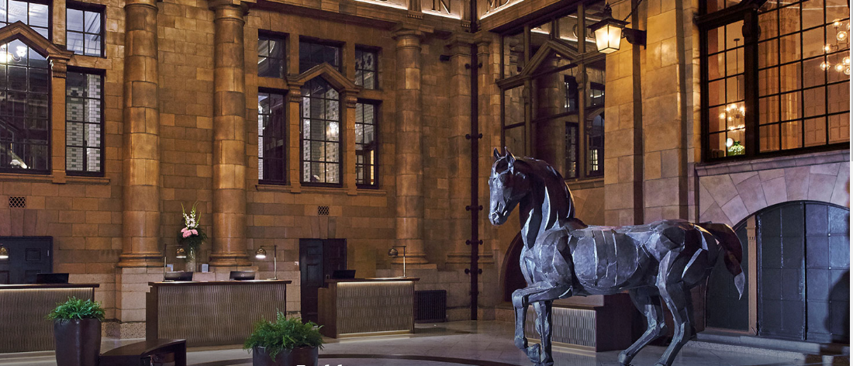
The Principal Hotel 4*
Oxford Street
M60 7HA
Website

Price: £145 including VAT and Breakfast
(A limited number of bedrooms are available)
BOOK BY 18th April - rates and availability cannot be guaranteed after this

- Formerly The Palace Hotel
- Completely refurbished to a high standard and rebranded under The Principal
- The NW Annual Dinner is taking place on the lower ground floor – so the bedrooms are onsite
- Located directly outside Oxford Train Station and an approximate 10 minute walk to Piccadilly Train Station
- Located close to Spinningfields and Deansgate
- 270 bedrooms with only 40 allocated to the group at this stage
- Extra bedrooms may be negotiated but possibly not at this low rate!
- Early booking is advisable
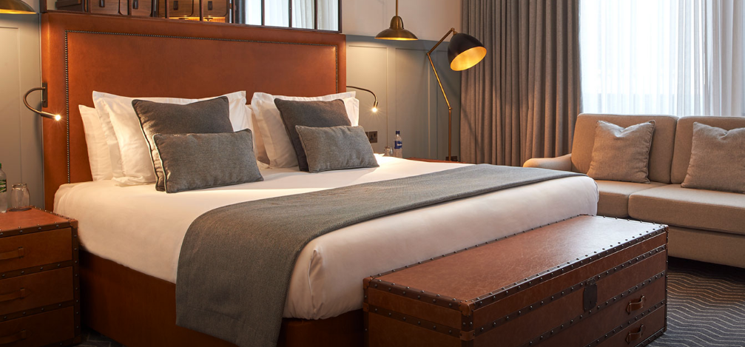
- Cancellation FOC up to 11th April – after that full charges will apply

To Book: Please email reservations@intelligent-venues.com

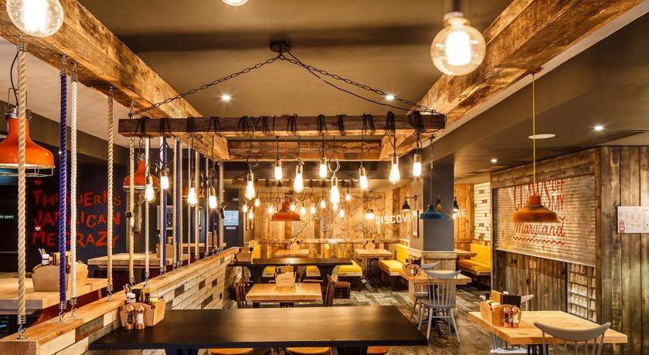
Ibis Styles 3*
3-5 Portland Street
M1 6DP
Website

Price: £80 including VAT and a Continental Breakfast
BOOK BY 18th April - rates and availability cannot be guaranteed after this

- Approximately a 7 minute drive or a 13 minute walk to The Principal Hotel
- An approximate 5 minute drive or walk from Piccadilly Train Station
- Formerly the Portland Hotel, this hotel has recently changed to an Ibis Styles
- 204 bedrooms that are weather themed and there is a quirky style running through the hotel
- There are 10 bedrooms allocated for the group
- Free wifi

To Book: reservations@intelligent-venues.com
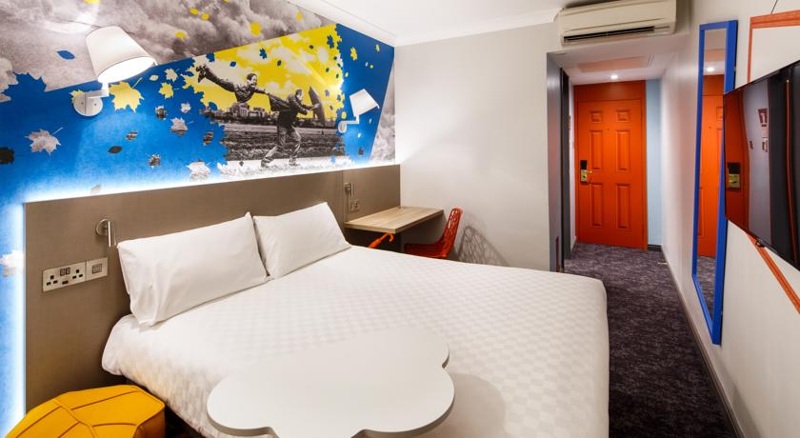

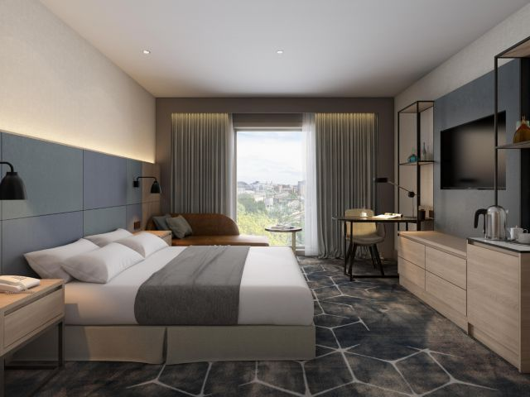
Crowne Plaza Oxford Road 4*
55 Booth Street West
M15 6PQ
Website

Price: £I19 including VAT and Breakfast
(A limited number of bedrooms are available)
BOOK BY 18th April - rates and availability cannot be guaranteed after this

- Brand New Build Hotel located just off Oxford Road
- The hotel is part of the IHG chain and a welcome new addition to Manchester
- Located next to Manchester Business School and an approximate 14 minute walk to Piccadilly Train Station and 10 minutes to The Principal
- Wifi included
- Cancellation FOC up to

To Book: reservations@intelligent-venues.com

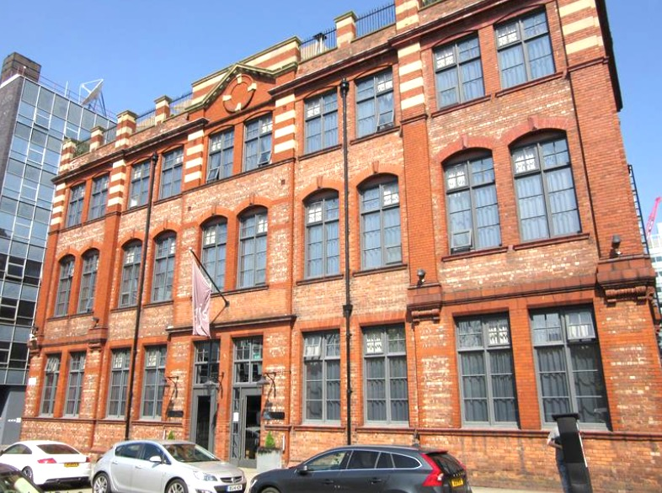
Great John Street Hotel (Boutique)
Great John Street
M3 4AW
Website

Price: £132 including VAT and Breakfast
(A limited number of bedrooms are available)
BOOK BY 18th April - rates and availability cannot be guaranteed after this

- An approximate 8 minute drive or a 15 minute walk to The Principal Hotel
- Approximately a 25 minute walk to Piccadilly Train Station and a 15 minute drive or walk to Oxford Road Train Station
- Located close to Spinningfields and Deansgate
- Boutique hotel with a cosy, homely feel
- The hotel has 30 bedrooms and booking is subject to availability
- The hotel used to be an old school house which is subtly shown throughout parts of the hotel
- Has a south facing roof terrace called ‘The Playground’
- The bedrooms are Duplex Style

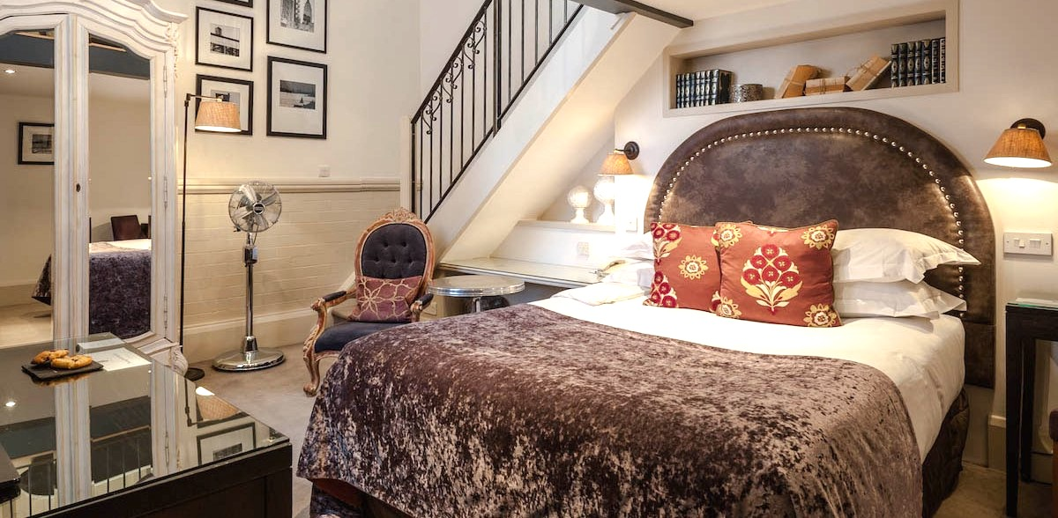
To Book: Please email reservations@intelligent-venues.com

